**KURUKSHETRA UNIVERSITY KURUKSHETRA**

(Established by the State Legislature Act XII of 1956)

("A+" Grade, NAAC Accredited)

**NOTIFICATION**

While considering the request of left-out University retirees/employees, the Director General Higher Education, Haryana, Panchkula has desired to intimate the names of eligible University employees/retirees of University who had not opted for Pension Scheme — 1997 earlier and now they want to change their option from CPF to Pension Scheme.

Accordingly, the retirees/employees who were appointed in the University services on or after 01-04-1995 and were/are continuing in service as on 01-04-1995 and had not opted for the Pension Scheme — 1997 earlier, are hereby advised to send their request(s) on the specified proforma enclosed herewith to the Pension Cell in triplicate to opt for Pension from CPF within 15 days from the date of publication of this notification in the newspapers, subject to condition that they have to deposit their CPF Share alongwith upto date interest @ rate applicable on PF from time to time, if Govt. approves the proposal. The emplyees/retirees, who had earlier applied for change of option are also required to apply afresh. This is the last opportunity to apply for change of their option. No application, in this regard, shall be entertained after the due date, in any circumstances.

However, it is reiterated that it may not be construed as any offer and the decision on the issue shall purely depend on the approval of the State Government.

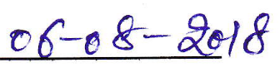**REGISTRAR**

**Endst.No.Pen/18/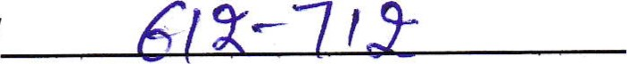Dated:**

Copy of the above is forwarded to the following with the request to bring the contents of this document in the knowledge of all the personnel working with them and in case of anybody being on leave/away during this period, the same may please be brought into his/her notice telephonically or through other appropriate mode like email etc. as no further opportunity would be available to any one after the last date:-

1. All the Chaipersons/Heads of Teaching & Non-Teaching Departments, K.U.

Kurukshetra.

1. Principal, University College, K.Ue Kurukshetra.
2. Principal, College of Education, K.U. Kurukshetra.
3. Manager, University Press, K.U. Kurukshetra.
4. Librarian, J.L.N. Library, K.U. Kurukshetra.
5. Director, I.T. Cell, K.U. Kurukshetra with the request to get this notification posted on the Unviersity Website.
6. Director, Public Relation Officer, K.U. Kurukshetra with the request to get this notification published in the two National Daily Newspapers.
7. OSD to Vice-Chancellor for kind information of the Vice-Chancellor, K.U. Kurukshetra.
8. P.A. to Registrar, K.U. Kurukshetra for informaton of the Registrar.
9. P.A. to Controller of Examination, K.U. Kurukshetra.
10. 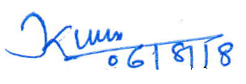P.S. to Finance Officer, K.U. Kurukshetra.

**Administrative Officer,**

**Accounts Branch-Il**

To

The Vice-Chancellor,

Kurukshetra University,

Kurukshetra.

**Subject: Grant of one more chance to change option from CPF to Pension Scheme.**

Sir,

Kindly refer to Notification No.Pen/18/612-712 dated 06-08-2018, I wish to change my option from CPF to K.U.E. Pension Scheme Rules – 1997.

I have gone through the Rules & Regulations relating to Pension Scheme introduced in the University w.e.f. 01-04-1995 and opt to be governed under the Kurukshetra University Employees Pension Scheme – 1997, if the State Govt. allows one more chance to left-out eligible employees/retirees of K.U. Kurukshetra.

It is requested that I may kindly be granted this opportunity.

Thanking you.

Yours faithfully,

Dated: ____________ (Signature of the Employee/Retiree)

Place: ____________ Name: _______________________

Designation: __________________

Office: ______________________

P.F. Account No. ______________

Date of Retirement _____________