PLACEMENT CELL
KURUKSHETRA UNIVERSITY, KURUKSHETRA
(Established by the state Legislature Act-XII of 1956)

PLACEMENT NOTICE

No. PC/2018/_______
Dated: 20.11.2018

Subject: - Campus Placement of B.Tech/M.Tech/MCA students in IBM India

Dear Students,
It is to intimate that the IBM India, is in the process of recruitment B.Tech (Computer Science/Electronics/IT/ Information Science/Electric and Electronics Engineering) /M.Tech /M.E/MCA students as Associate System Engineer. In this regard, all the eligible and interested students of Kurukshetra University and its affiliated institutes who have completed their degree in 2018 are required to fill their details in Google Doc attached herewith by 24th Nov. 2018. The campus placement drive will be held in the month of Dec. 2018. Kindly read all related documents carefully.
Eligibility Criteria:-
Academic Credentials/ Eligibility –
1. Course Completion Year: 2017/2018(Only candidates, who have completed & cleared their educational degree and have all Semester Mark sheets should apply)
2. Degree Courses: Graduation and Post-Graduation - B.E/ B.Tech/ MCA– 65% or 6.5 CGPA. (Calculation of qualifying marks =Sum total of marks obtained divided by Sum total of maximum marks obtainable. All subjects will be considered including elective/optional subjects)
3. No current /past backlogs.
Category | B.E/B.Tech Branches | MCA
 | Computer Science Engineering / Computer Engineering | Master Of Computer Application
 | Information Science and Engineering / Information Technology
 | Electrical and Electronics Engineering
 | Electronics and Communication Engineering
Academic Credentials/ Eligibility –
1. Course Completion Year: 2017/2018(Only candidates, who have completed & cleared their educational degree and have all Semester Mark sheets should apply)
2. Degree Courses: Graduation and Post-Graduation - B.E/ B.Tech/ M.E./ M.Tech – 65% or 6.5 CGPA.
SSLC / Xth, HSC / PUC / XII, Diploma or Equivalent - 60% or 6.0 CGPA. (Calculation of qualifying marks =
Sum total of marks obtained divided by Sum total of maximum marks obtainable. All subjects will be considered including elective/optional subjects)
3. No current /past backlogs.
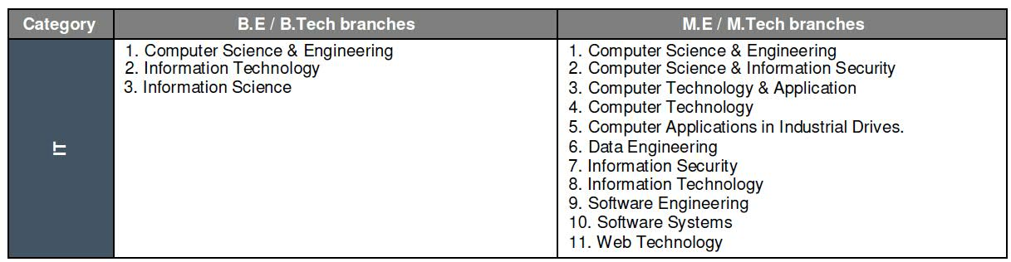

This is an Off Campus hiring for an entry level position, and the candidates should have completed their final year of education and should have obtained their degree prior to start of employment with IBM.
- Neither IBM India Pvt. Ltd. nor any of its subsidiaries (collectively 'IBM'), nor any authorized third party who assists with our recruitment process, ever ask candidates for 'recruitment', 'processing' or any other kind of fees in exchange for offer letters from IBM. Offer letters and other recruiting correspondence from IBM are sent from an official e-mail id and/or are printed on IBM letterhead with authentic signatures of appropriate IBM authorities

Important***
Form Link
https://goo.gl/forms/RimIuuDZedSjnwDo2

Placement Officer

