Journal of Haryana Studies
Journal of Haryana Studies is sponsored, edited and published annually by Kurukshetra University, Kurukshetra since 1969. It is a peer-reviewed journal. All submitted research papers are sent for a blind review by the experts of respective subjects/ fields.
Medium of Publication: Multilingual including English, Hindi, Punjabi, Sanskrit
Scope and Utility of the Journal: The Journal is open to contributions on Haryana issues, both theoretical and empirical in nature. Original studies about Haryana’s history, culture, language, literature etc. are invited.
The Journal of Haryana Studies has its own utility and significance as it provides an excellent forum for dissemination of information pertaining to Haryana for last more than five decades.
Editorial Board
Editor-in-Chief
 | Prof. Dinesh K. Gupta  Dept. of Lib. & Inf. Sc. | 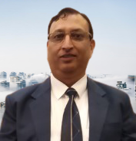
Associate Editors
 | Prof. Neera Verma  Dept. of Economics | 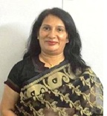
 | Prof. Manoj K. Joshi  Dept. of Lib. & Inf. Sc. | 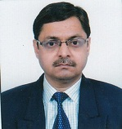
Editors
 | Prof. Tejinder Sharma  Dept. of Commerce | 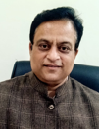
 | Prof. Sunita Siroha  Dept. of English | 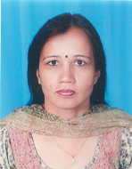
 | Prof. Subhash Chand  Dept. of Hindi | 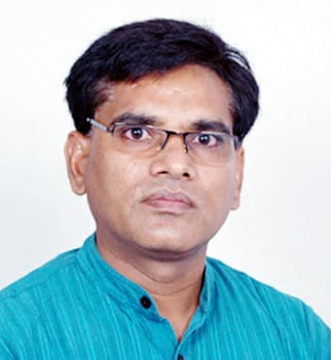
 | Dr. Vibha Aggarwal  Dept. of Sanskrit, Pali & Prakrit | 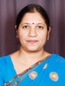
 | Prof. Sanjeev Aggarwal  Dept. of Physics | 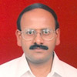
 | Dr. Pawan Kumar  Dept. of Fine Arts | 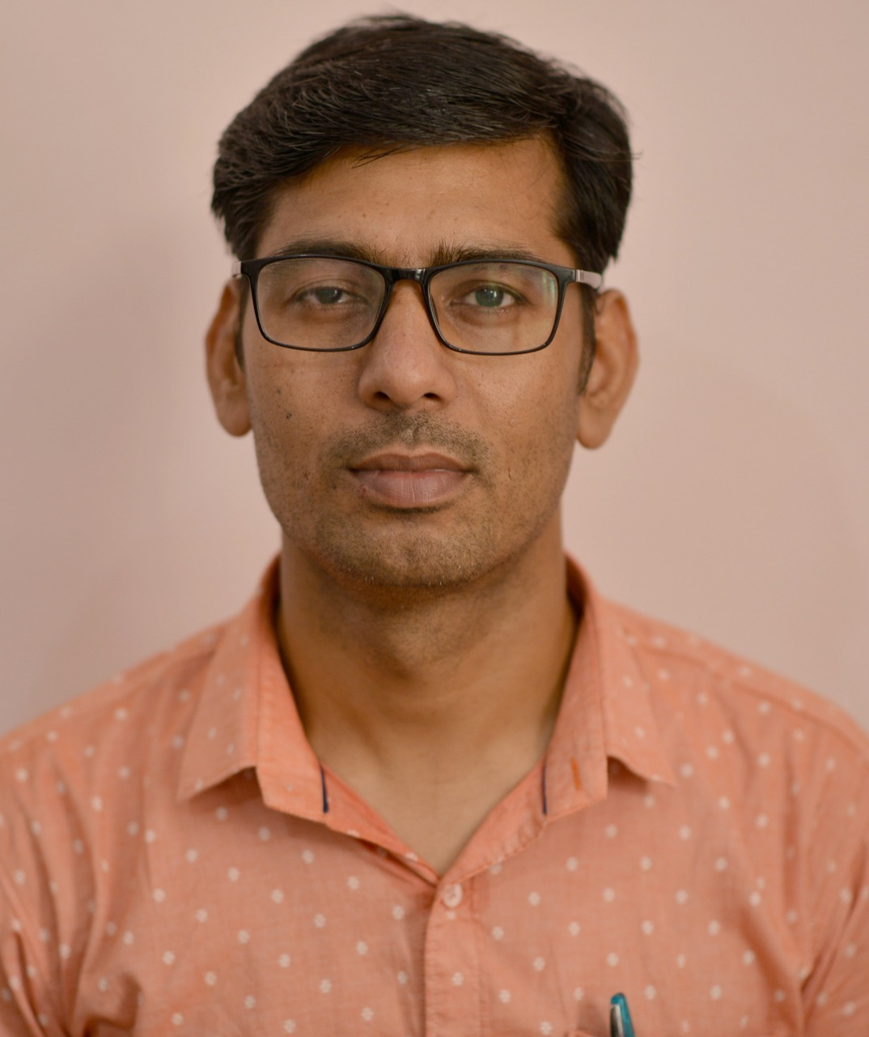
 | Dr. Kuldeep Singh  Dept. of Punjabi | 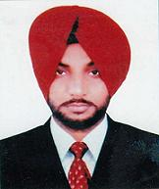
 | Dr. Jitender K. Bhardwaj  Dept. of Zoology | 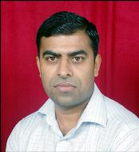
Media Advisor
 | Dr. Ashok Sharma  Dept. of Mass Communication & Media Technology | 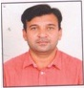

Contact us
jhs@kuk.ac.in
editor_jhs@kuk.ac.in

