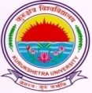
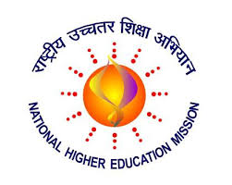
KURUKSHETRA UNIVERSITY RUSA PROJECT SOCIETY

Kurukshetra University RUSA Project Society invites applications for following Short term courses under RUSA 2.0.

Opening date for submission of applications: 12.10.2019

Closing Date for submission of applications extended upto: 15.12.2019

Display of admission List: 19.12.2019. Fee deposit 19.12.2019 and 20.12.2019.

Commencement of Classes: 01.01.2020

Certificate Course Name | Eligibility | Intake
Vastu Shastra & Indian Interior Design | 10+2 | 30
Marathi Language | Graduation | 30
Refer to Kurukshetra University, Kurukshetra website www.kuk.ac.in for more details.

NODAL OFFICER RUSA

