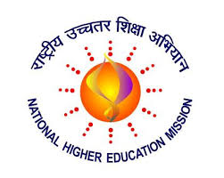
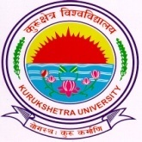
KURUKSHETRA UNIVERSITY RUSA PROJECT SOCIETY (KURPS)

______________________________________________________________________________________________
Dated: 27 November, 2019

Result of Walk-in-Interview held on 22nd and 23rd November, 2019 in the O/o Dean Academic Affairs, Kurukshetra University, Kurukshetra for the engagement of Scientific Officer(s)/Incubation Consultant/ Junior Engineer(s) under RUSA 2.0 project.

Sr. No. | Name of Research Centre | Designation | Selected Candidates
1 | Centre for Applied Biology in Environment Sciences | Scientific Officer | Nil
2 | Centre for Advanced Material Research | Scientific Officer | Nil
3 | Centre for IT and Automation | Scientific Officer | - Ms. Shubhanshi Singhal
4 | Incubation Centre | Incubation Consultant | - Dr. Srinadh Mattaparthi
5 | Construction Branch | Junior Engineer (Civil)  Junior Engineer (Electrical) | - Sh. Ankit Kumar  - Sh. Gourav

Sd/-
NODAL OFFICER RUSA, KURPS

