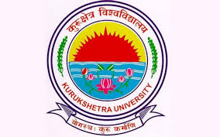
Department of Physical Education,
Kurukshetra University Kurukshetra
(Established by the State Legislature Act-XII of 1956)
(A⁺ Grade NAAC Accredited)
Dr.(Mrs.) Usha Rani
Professor Notice

The Department of Physical Education is organizing an awareness programme on “Immunity Enhancement through Yoga in fighting COVID-19” on 12-05-2020 from 6:00am to 8:00 AM. This Programme will be organized on Facebook link https://www.facebook.com/Deptartment-of-Physical-Education-KUK-112066057165855/. Hon’ble Vice-Chancellor will inaugurate the programme. Prof. Praveen Kumar Tripathi, Head of the Department of Humanities, City University, Ludhiana (Punjab) will be key speaker.
All the Deans, Chairpersons/Directors of the University Teaching Departments/Institutes and Principals of the affiliated Colleges are requested to attend the programme as per above scheduled date and time.
Chairperson

Endst. No. PE/20/148-447 Dated: 09-05-2020.
A copy of the above is forwarded to the following for information and necessary action.
- Dean Academic Affairs, KUK.
- All the Deans, Chairpersons/Directors/Principals of University Teaching Departments/Institutes and affiliated colleges/institutes, KUK.
- Director, IT Cell, KUK with a request to upload the notice on the University website.
- Director, Public Relations, KUK for issuing press release for wide publicity.
- Prof. In-charge, IQAC, KUK.
- OSD to Vice-Chancellor, KUK (for kind information of the vice-chancellor, please)
- Supdt. o/o of the Registrar

Chairperson

